Assignment -4

Docker and Kubernetes

|  |  |
| --- | --- |
| Assignment Date | 21 October 2022 |
| Student Name | SURYA NARAYAN M S |
| Student Roll Number | 1905147 |
| Maximum Marks | 2 Marks |

1. **Pull an image from Docker hub and run it in Docker Playground**

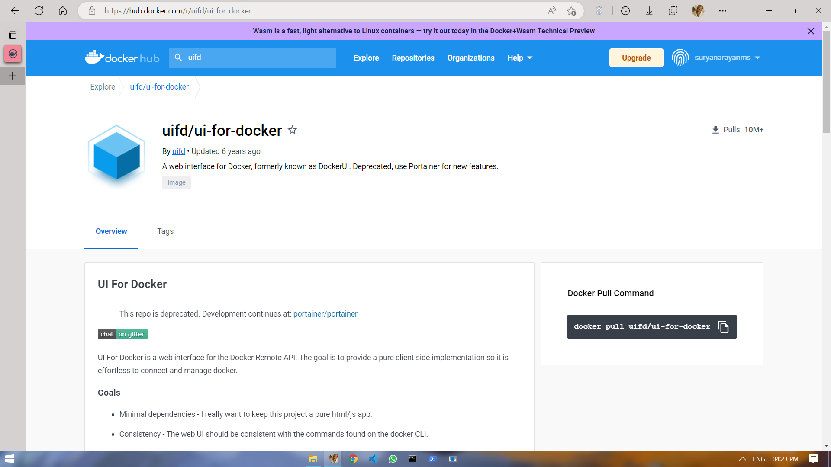

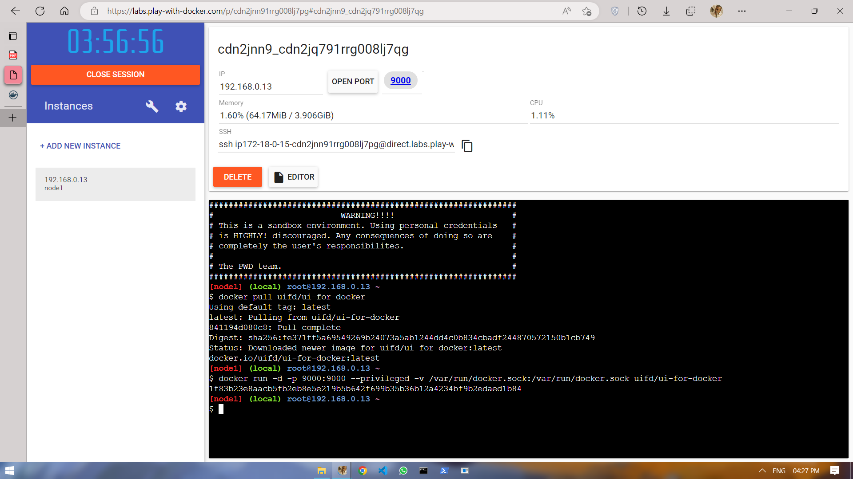

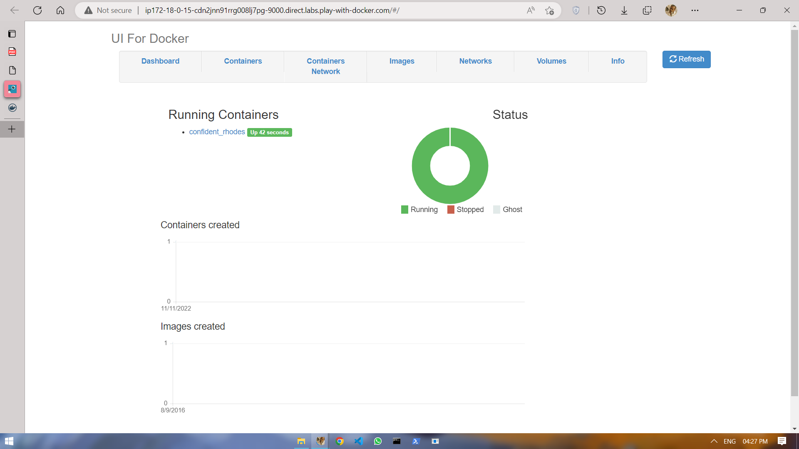

1. **Create a Docker file for the job portal application and deploy it in Docker desktop application**

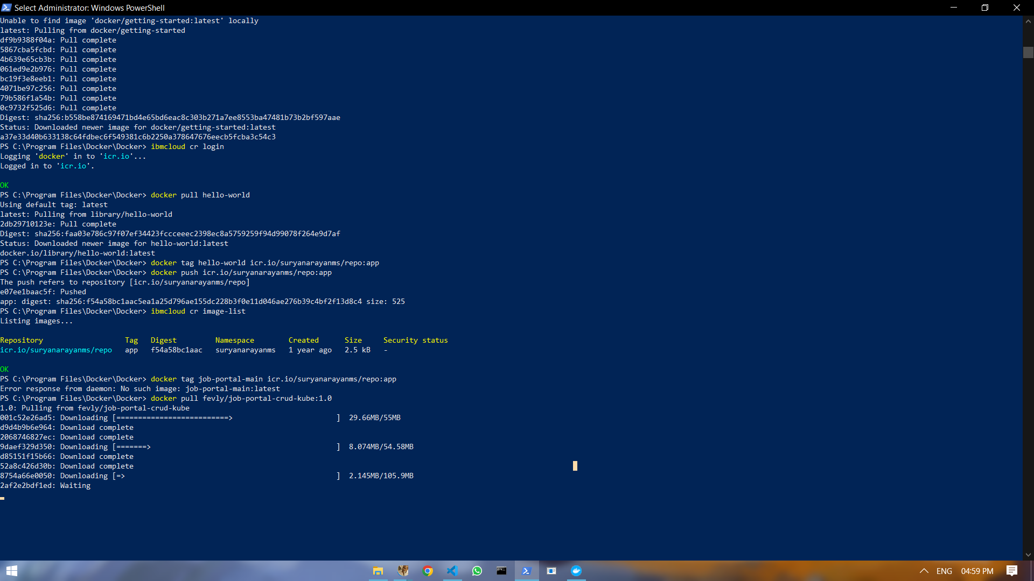

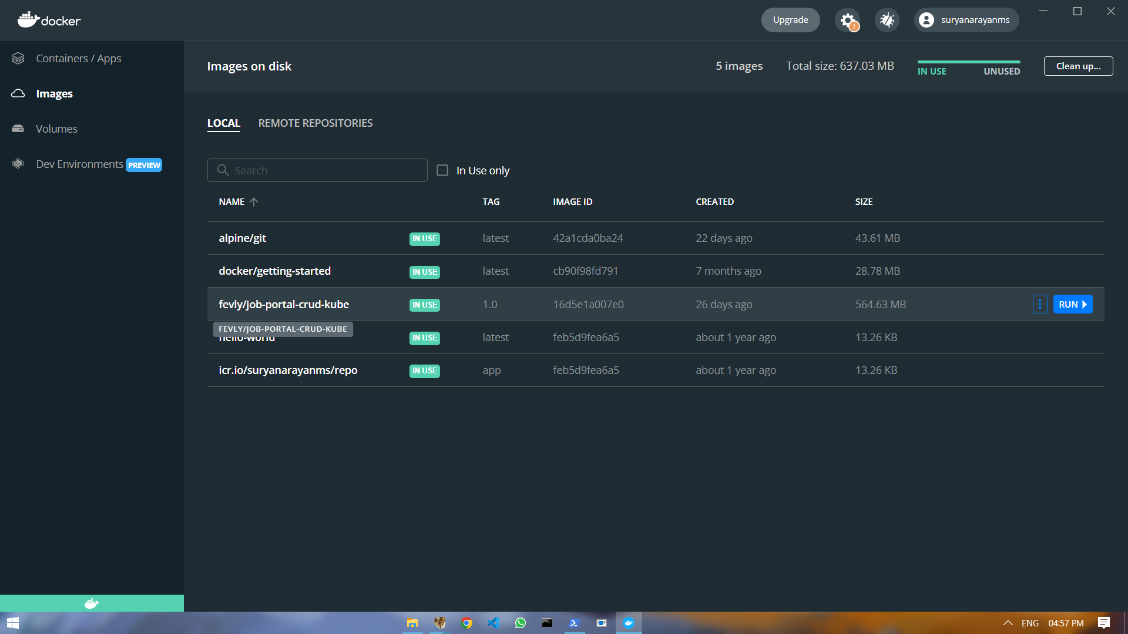

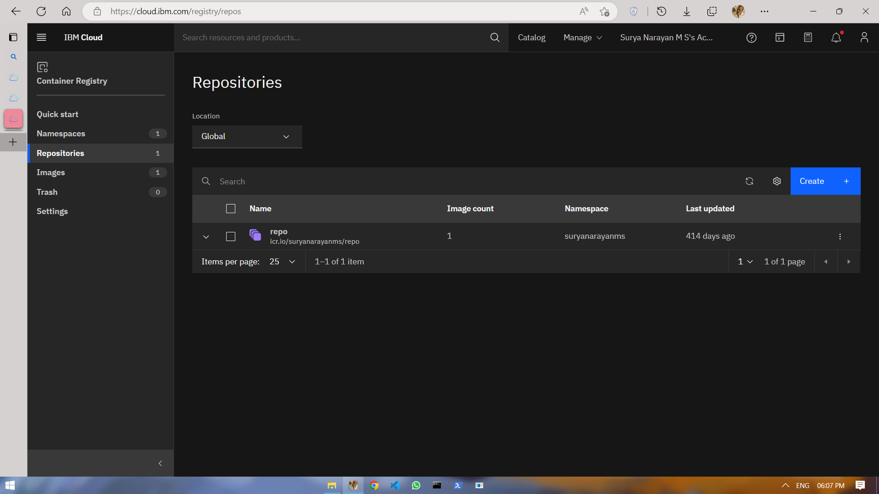

1. **Create a IBM container registry and deploy hello word app**

